**What’s New?**

**1. TDS Integration – Simplified Deposit Management**

We’ve introduced seamless integration with the **Tenancy Deposit Scheme (TDS)** to make deposit management faster, easier, and fully compliant.

**Getting started is easy:**

* Email TDS to request your Branch ID, Member ID, and API Key.
* Share these details with us to connect your TDS account to AMC.
* Submit deposit information with a single click – the **Deposit Account Number (DAN)** will appear in AMC within 5–7 minutes.
* Use the DAN as your payment reference when making payments to TDS.

This integration ensures **full compliance with TDS regulations**, reducing manual errors and making the process more efficient.

For setup assistance, contact your account manager at **+44 117 325 2892**.

**2. Editable Email & SMS Templates**

We’re introducing a new feature in AMC that allows users to **edit existing email and SMS templates directly within the system**.

This feature will be released in the next AMC update, after which you can access it under **Settings > Template Library**.

**Click below to learn how to edit email/SMS templates**



**3. Sales & Lettings Items Checklist**

To help you stay organized, we’ve introduced a new feature that allows you to **create checklists for your employees**, ensuring no steps are missed when letting or selling a property.

To enable this feature, contact your account manager. Once activated, you’ll find it within each property.

**Click below** to learn how to add a checklist



**4. Canopy Tenant Referencing – Faster & Smarter**

1. We’re excited to announce our integration with **Canopy**, making tenant referencing quicker and more reliable.
2. **Why Canopy?** ✅ **Speed & Efficiency** – Automated checks reduce processing time, ensuring quicker tenancy approvals.  
   ✅ **Comprehensive Screening** – In-depth credit, affordability, and rental history checks.  
   ✅ **Better Decision-Making** – Instant insights to help you choose the best tenants.  
   ✅ **Seamless CRM Integration** – Everything is handled within AMC for a smoother process.

**How It Works:**

* 1. Email Canopy to receive your unique API key after subscribing.

2. Place a tenant referencing order in AMC with one click.

3. AMC will automatically share tenant details to initiate the process, and once referencing is complete, the status will automatically update in AMC.

This means **less hassle, more accuracy, and a better experience for landlords and tenants alike**.

This integration means **less hassle, more accuracy, and a better experience for landlords and tenants alike**. If you have any questions or would like a demo, feel free to get in touch!

**5. Rightmove Tenant Referencing – Quick & Easy**

**We’ve also integrated with Rightmove Tenant Referencing to provide a faster, more efficient way to conduct tenant checks.**

**How to get started:**

1. **Email Rightmove to receive your unique API key after subscribing.**
2. **Place a tenant referencing order in AMC with a single click.**
3. **AMC will automatically share tenant details, and once referencing is complete, the status will update in AMC.**

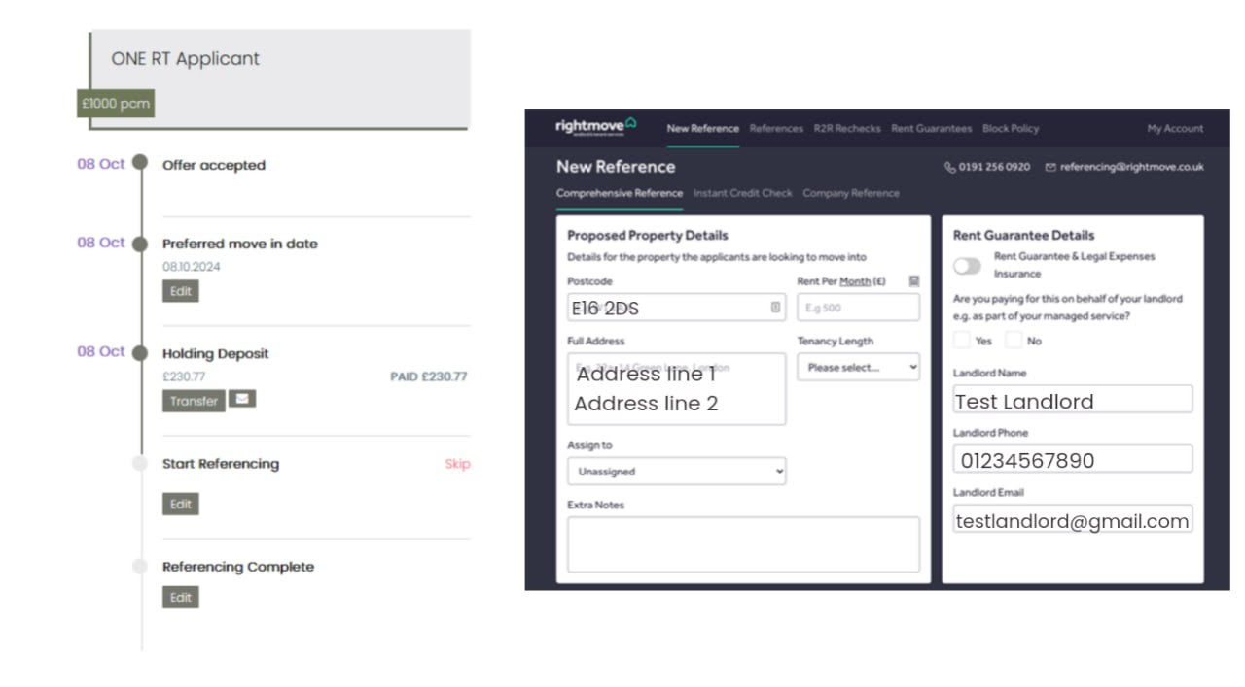

**6. EPC Uploads to property**

We’ve added a new feature that allows you to **quickly check if a property has a valid EPC certificate** before listing it. You’ll find this option under each property’s details in AMC.

This option would be available for you under each property as shown in the image below:

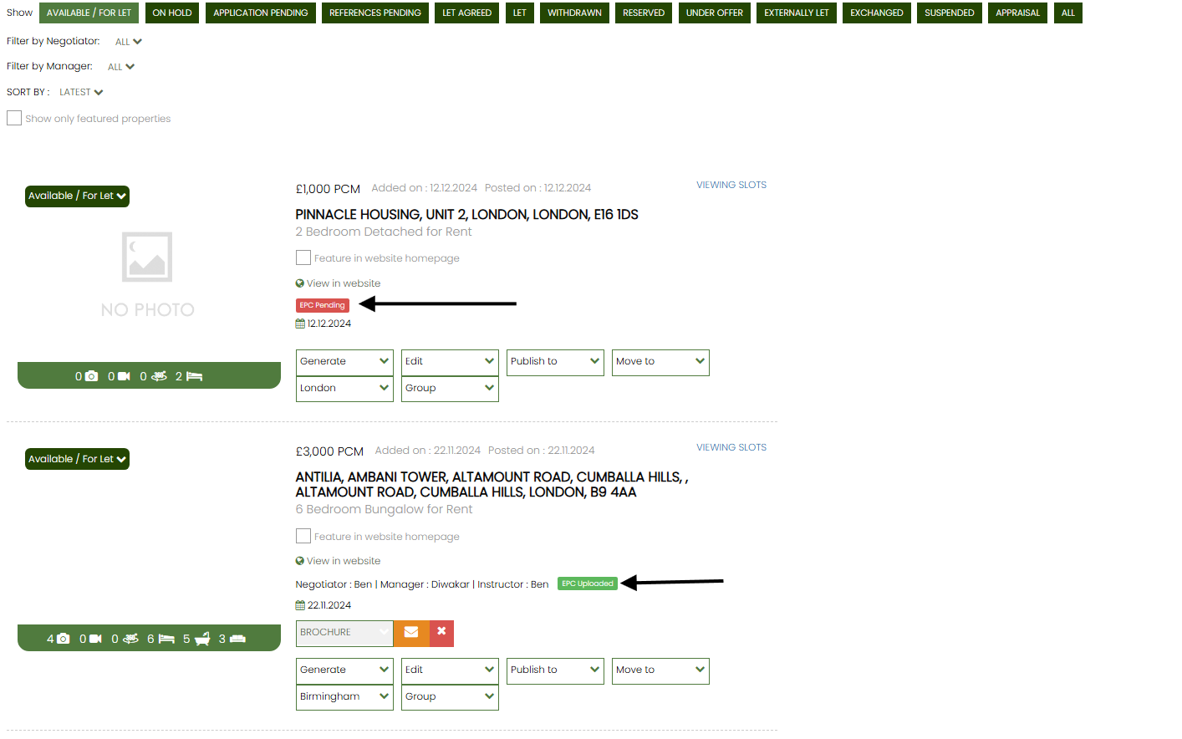

**7. VALPAL Integration – AI-Powered Lead Qualification**

Our integration with **VALPAL** will help you manage leads more efficiently. This comes just ahead of the launch of **ValPal Pro**, an AI-powered upgrade that enhances communication via AI-driven voice, text, and email.

With this integration, **ValPal customers using GNB software can now work seamlessly, eliminating the need for duplicate data entry**.

**8. Membership Certificate Expiry Reminders**

We’ve added an automated notification system to alert agencies when their uploaded **membership certificate has expired**.

You’ll receive an **email notification** and see a **red alert strip** in AMC, prompting you to upload the renewed certificate.

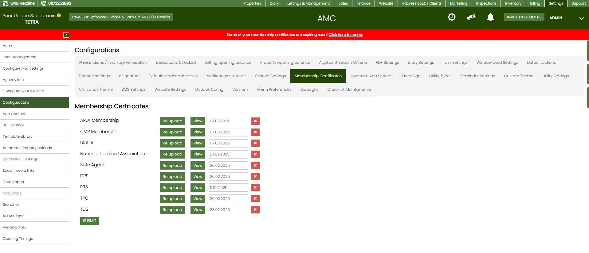

We hope these updates improve your workflow and enhance your experience with AMC. If you have any questions or need assistance, feel free to contact your account manager.

**Best regards,**